Contents
Background 1
Replacement Contract has been processed – Delete replacement and reinstate previous post 1
Additional Contract has been processed – Delete additional contract 2
Contract Amendment has been processed – Delete latest appointment sequence 2
Configuration 2
How to Delete a Contract 2
How to Delete a Contract Amendment 4
Additional Information 5
Applicant impact 5
HR Audit Report 5

Background
New functionality providing the ability to delete an employee’s appointment when processed in error either by way of replacing contract (transfer) or as a new additional contract. In addition, the ability to delete the latest appointment sequence if processed in error.
The delete contract functionality can be used for the following process scenarios:

Replacement Contract has been processed – Delete replacement and reinstate previous post
To be eligible for deletion a new replacement contract/appointment can either be appointed or commenced, but only where the new post has not been paid. Where a post has already been paid, a message is displayed stating that contract can’t be deleted.
Where the new replacement contract/appointment has already been ended, it can’t be deleted.
For replacement contracts, all previous post data will be reactivated. Appointment status is reversed and salary and cost allocation set as active.
The new replacement contract will be deleted, including salary, allowances, pensions, UDF’s.
Alternative Outcome
If the contract is the employee’s first and only substantive appointment the button to delete the contract will instead go through the screens for switching the appointment for a different one. This process allows the employee to keep their current appointment ID however, the post number and post sequence changes to the post that have been switched to. The posts available for selection need to be authorised in advance of selection.

Additional Contract has been processed – Delete additional contract
To be elegible for deletion the new additional contract can be either appointed or commenced, but only where the new post has not been paid. If the additional post has been paid, a message is displayed stating that contract can’t be deleted.
If the new additional contract/appointment has already been ended, it can’t be deleted.

For additional contracts, when the delete contract function is triggered the contract will be deleted, including salary, allowances, pensions, UDF’s.

Contract Amendment has been processed – Delete latest appointment sequence
The latest appointment sequence is deleted and previous sequence reactivated. No impact on salary etc.

Configuration
Menu options that require enabling:

System | Menu Option | Menu ID
People Management | PEOPLE MANAGEMENT | MAIN_MENU.PEOPLE_MANAGEMENT
People Management | HR ADMIN | PEOPLE_MANAGEMENT_MENU.HRADMIN
People Management | EMPLOYEE DASHBOARD | HRADMIN_MENU.EMPLOYEE_DASHBOARD
People Management | DELETE CONTRACT AMENDMENT | EMPLOYEE_DASHBOARD_MENU.DELETE_CONTRACT_AMENDMENT
Web Services | Profile | MAIN_MENU.WS_PROFILE
Web Services | Delete appointments | WS_PROFILE_MENU.DELETE_APPOINTMENTS_ID
Web Services | Delete appointments Proxy (Pers Post Access) | WS_PROFILE_MENU.DELETE_APPOINTMENTS_ID_PROXY
Web Services | Get appointments linked items | WS_PROFILE_MENU.GET_APPOINTMENTS_LINKED_ITEMS_ID
Web Services | Get appointments linked items talent | WS_PROFILE_MENU.GET_APPOINTMENTS_LINKED_ITEMS_TALENT_ID
Web Services | Update appointments | WS_PROFILE_MENU.PATCH_APPOINTMENTS_ID

How to Delete a Contract
System process steps for deleting contracts.
- Go to the Command Centre tab on the People Management dashboard.
- Click the View button on the Employee section.
- Search for the employee in question that is due to be deleted.
- On the HR Employee Dashboard, go to the Contracts section
- Click on the ellipsis button on the Summary section.
- The Delete Contract button is available to use.
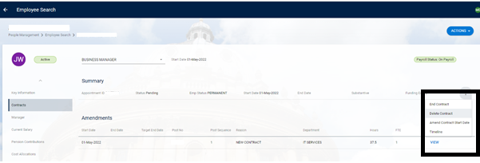
- After clicking on Delete Contract a confirmation message is displayed, noting the Appointment ID and confirming any additional linked items that will also be deleted, for example Salary. Click OK to proceed.
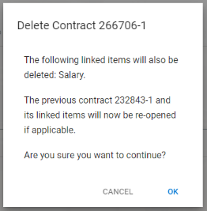

Alternatively, if the contract is the employee’s first and only substantive appointment the button to delete the contract will instead go through the screens for switching the appointment for a different one. This process allows the employee to keep their current appointment ID however, the post number and post sequence changes to the post that have been switched to. The posts available for selection need to be authorised in advance of selection.
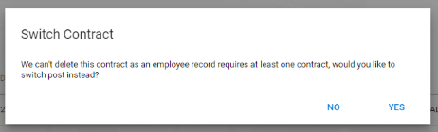

How to Delete a Contract Amendment
System process steps for deleting contracts.
- Go to the Command Centre tab on the People Management dashboard.
- Click the View button on the Employee section.
- Search for the employee in question.
- On the HR Employee Dashboard, go to the Contracts section of the employee record.
- Select the Amendment that is required to be deleted, i.e. appointment sequence and click on the View button.
- Within the View Contract screen, click on the Delete button.
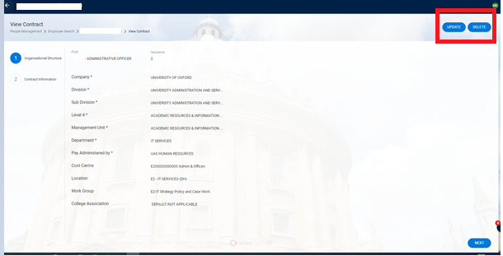
- After clicking on Delete Contract a confirmation message is displayed.
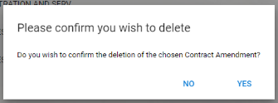
- Click Yes to continue.

Additional Information
To assist with investigative purposes the following information has been provided to advise the relation with applicants and the audit report used by HR Systems when the delete functionality is used.

Applicant impact
Scenario: An applicant who is already an existing employee has been appointed via the replace contract process, and then the new replacement appointment is deleted. In this situation, the applicant remains listed against the vacancy but the post appointment is removed from the offer details screen.
The new post is still shown linked to the original vacancy, but would not be available to reselect in order to record an offer for another candidate or process as a direct appoint. A new planned appointment would be required in that circumstance.

HR Audit Report
Where a contract has been deleted details of the post appointment are still present on the audit report, but show ‘delete’ within the audit type and field name columns.

